Practical - 1
Practical Title: Project Initiation, Requirement Analysis, Sitemap, Wireframe, and GitHub Setup

Problem Definition: Initiate the semester-long StudentHub portal by identifying the problem scope, user roles, key modules, navigation flow, and minimum 10 pages. Create a sitemap, low-fidelity wireframe, project folder structure, README file, and GitHub repository.

Theory

What is URL and parts of URL?
Answer: A URL is the address of a webpage or any file on the Internet. It helps the browser find and open the required webpage.
EX. https:// www.google.com

How does HTML file process in web browser?
Answer: When we enter a website address or open an HTML file, the web browser first reads the HTML code. It understands the tags and creates the structure of the webpage. Then it loads the CSS to apply colors, fonts, and layout, and runs JavaScript to make the page interactive. Finally, the browser displays the complete webpage on the screen.

3. How will page navigation flow managed among all HTML pages?
Answer: Page navigation is managed by using hyperlinks (<a> tags) in HTML. Each page contains links that connect it to other pages of the website. When We clicks a link, the browser opens the corresponding HTML page. Navigation menus, buttons, and links help users move from one page to another easily.

4. How will GitHub commits be maintained after each practical?
Answer: After completing each practical, I will save all the updated files and commit the changes to my GitHub repository. Every commit will have a clear message describing what was done in that practical. Then I will push the commit to GitHub so that all changes are stored online and the progress of each practical is maintained.

Output:-
Requirement Analysis:-
- User Login and Registration
- Student Dashboard
- Profile Management
- Attendance Tracking
- Assignment Details
- Course Information
- Result Viewing
- Notices and Events
- Contact/Feedback
- Easy Navigation and Secure Login

SiteMap:-
STUDENT HUB PORTAL
│
├── Home
| ├── Login
│ ├── Register
│ ├── Dashboard
│ ├── Profile
│ ├── Attendance
│ ├── Assignment
│ ├── Course Info
│ ├── Result
│ └── Contact Us
│
├── Dashboard
│ ├── Home
│ ├── Profile
│ ├── Attendance
│ ├── Assignment
│ ├── Course Info
│ ├── Register
│ └── Contact Us
│
└── Result
└── Result Page

Wireframe:-
I’ll puted their photo in Evidence for all 10 pages.

Evidence of Work (Screenshots)

1.Index Page:-
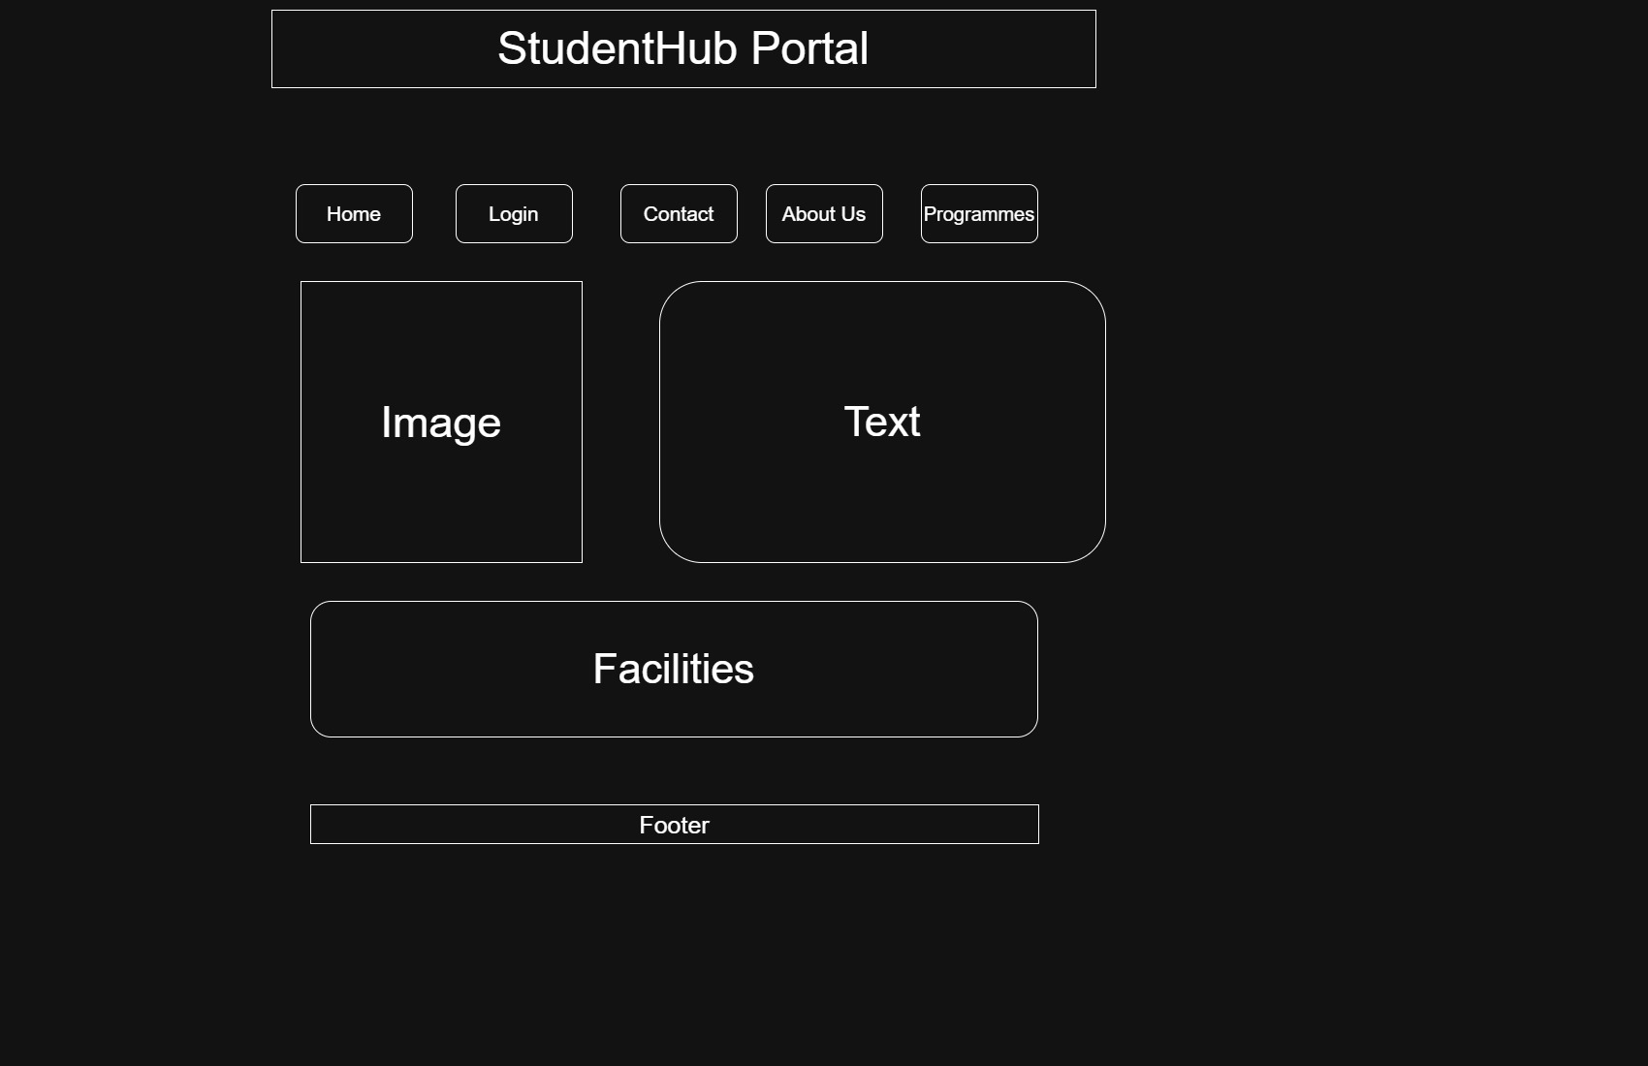
2.Login Page:-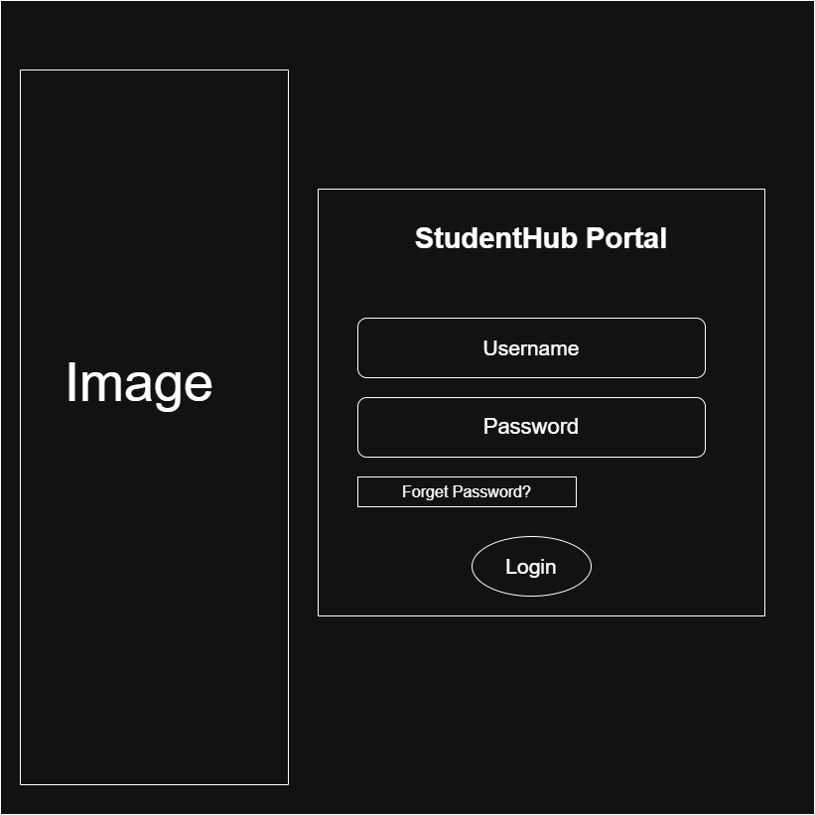
3.Registration Page:-
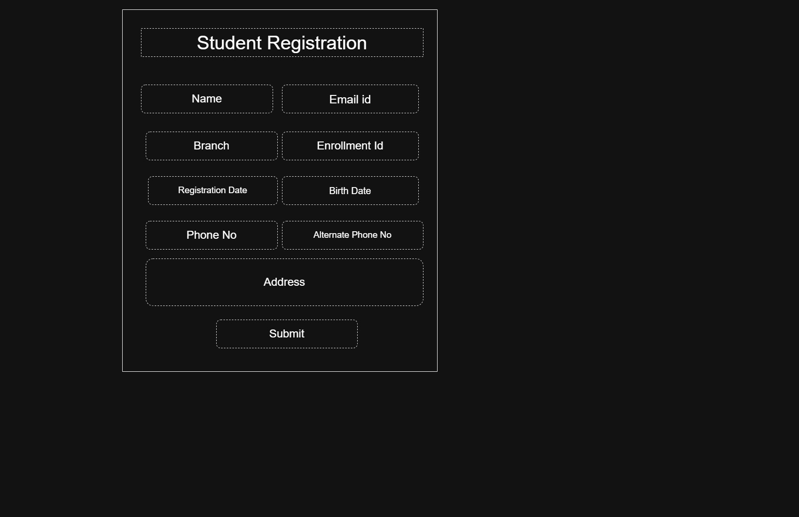
4.Profile Page:-
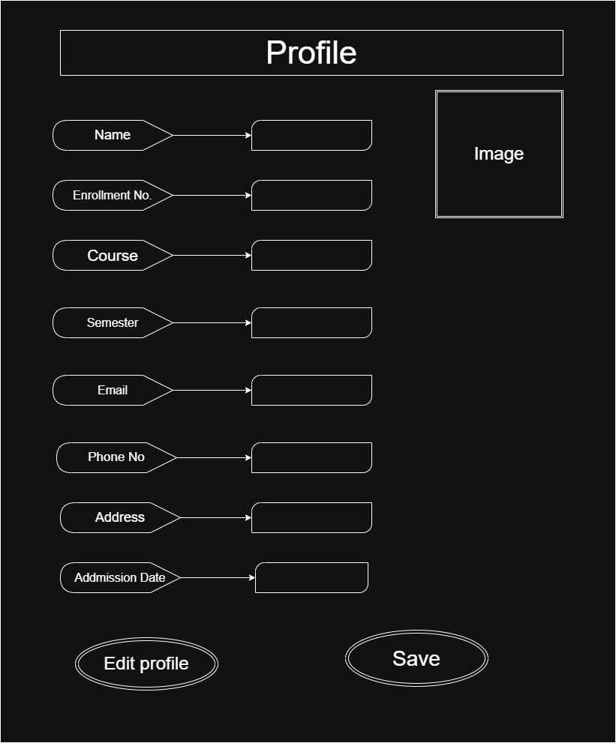

5.Dashboard Page:-
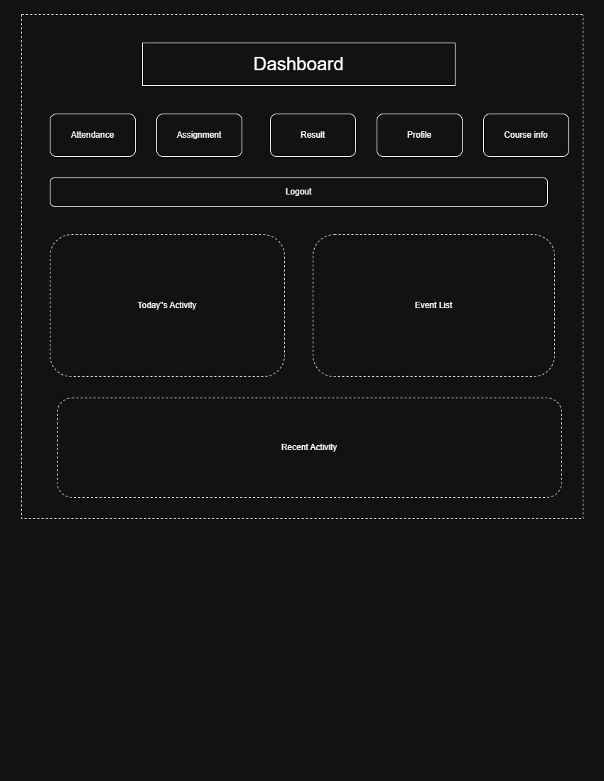

6.Assignment Page:-
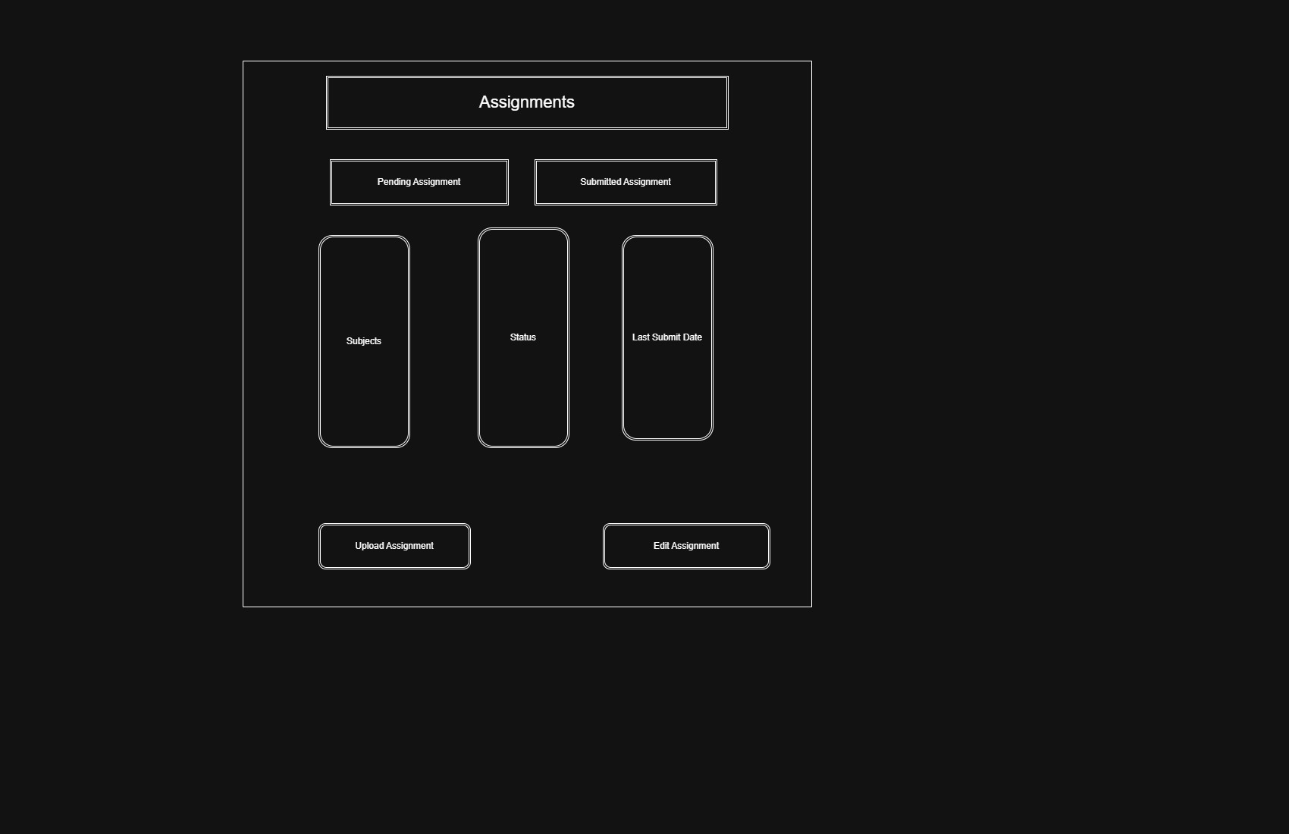
7.Attendance Page:-
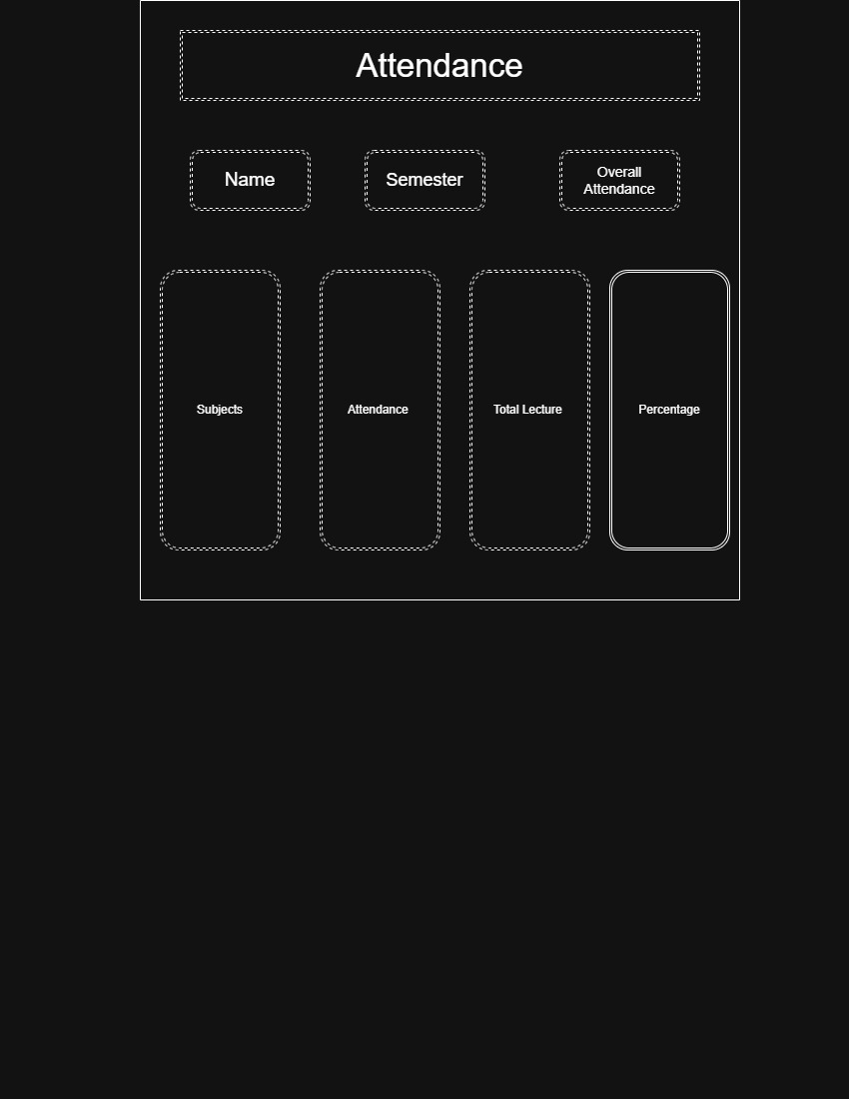
8.Course Info page :-
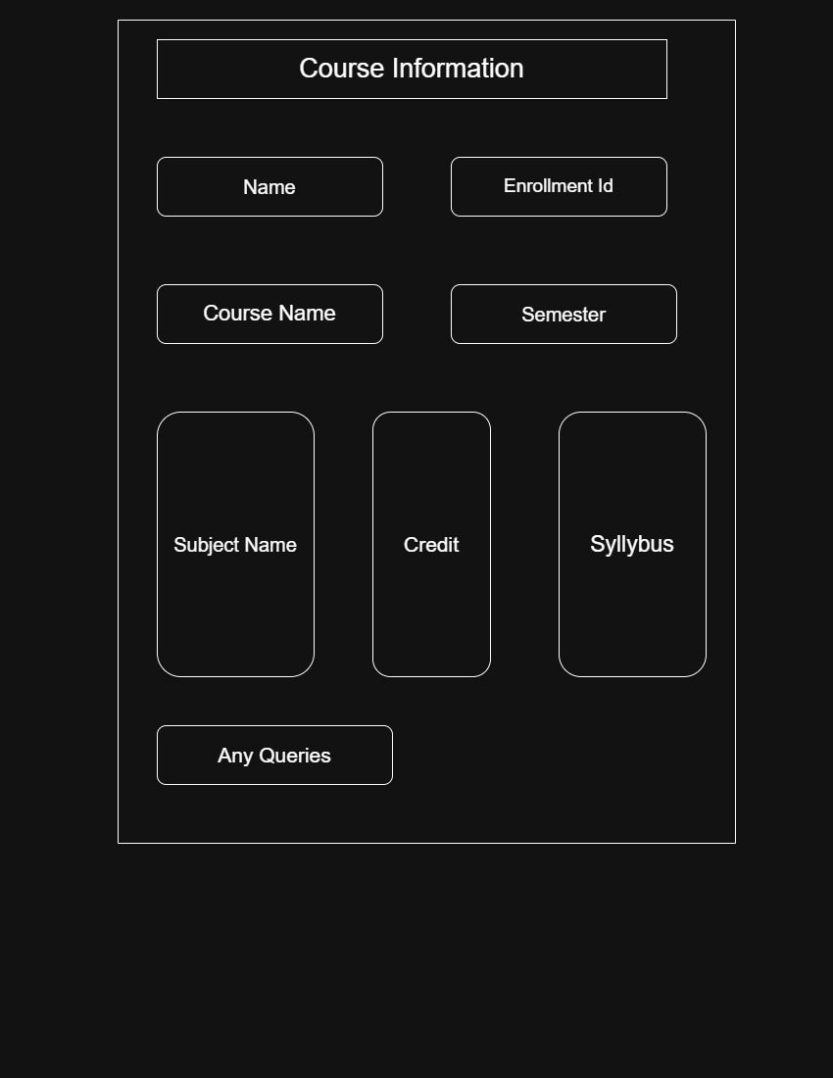
9.Result Page:-
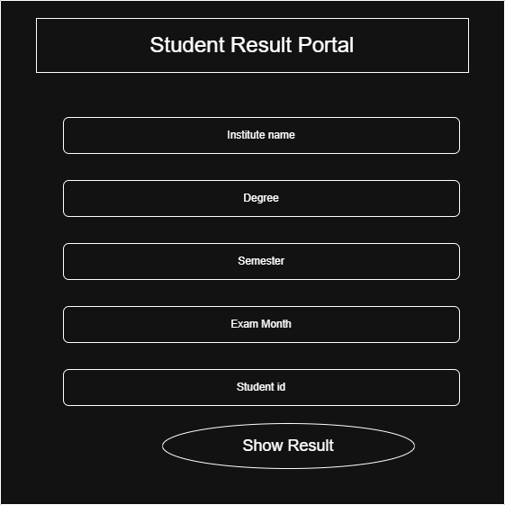
10.Contact page:-
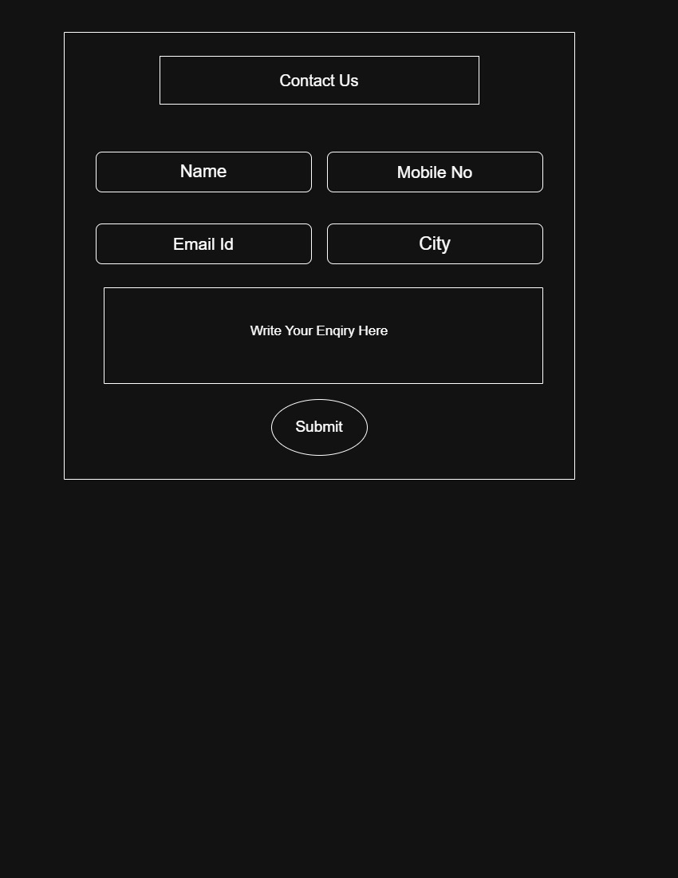

GitHub Repository Link:

https://github.com/Niket-Borad/StudentHub-Portal

Challenges Faced:
Like Where to Which tupe of Content like text,image ,Navigation bar.
Also Confused about a Navigation to One page to another page.

Learning Outcomes:
I Learn How to start Make Any Website Like What We do First. It Was make it clear about base foundation of any website.

Faculty Remarks:

